**State** is a Selection field that represents different stages of a record (e.g., "Draft", "Confirmed", "Done").

**Status Bar** is a UI element in Odoo that visually displays the current state and allows users to transition between states.

* the **State** (also called "Stage" or "Status") is a field used to track the progress of a record in a business workflow. The **Status Bar** is a visual representation of these states in the form of a progress indicator.

**Step 1: Define the Model (models.py)**

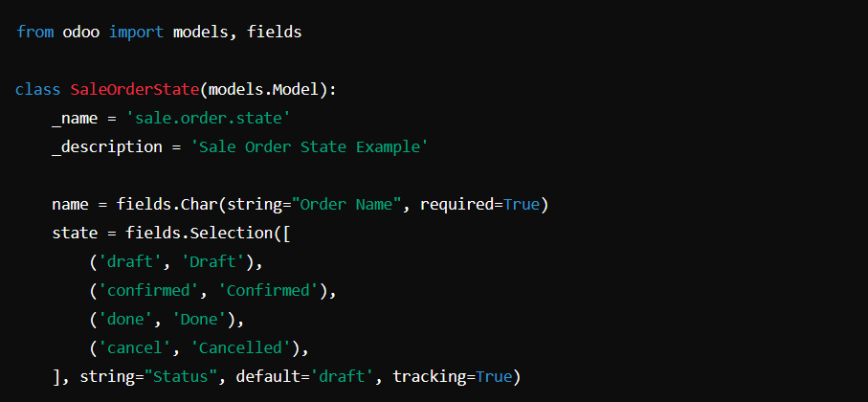

* The state field is a Selection field with predefined values.
* The default value is set to 'draft'.
* The tracking=True option enables tracking in the chatter.

**Step 2: Add the Status Bar in the View**

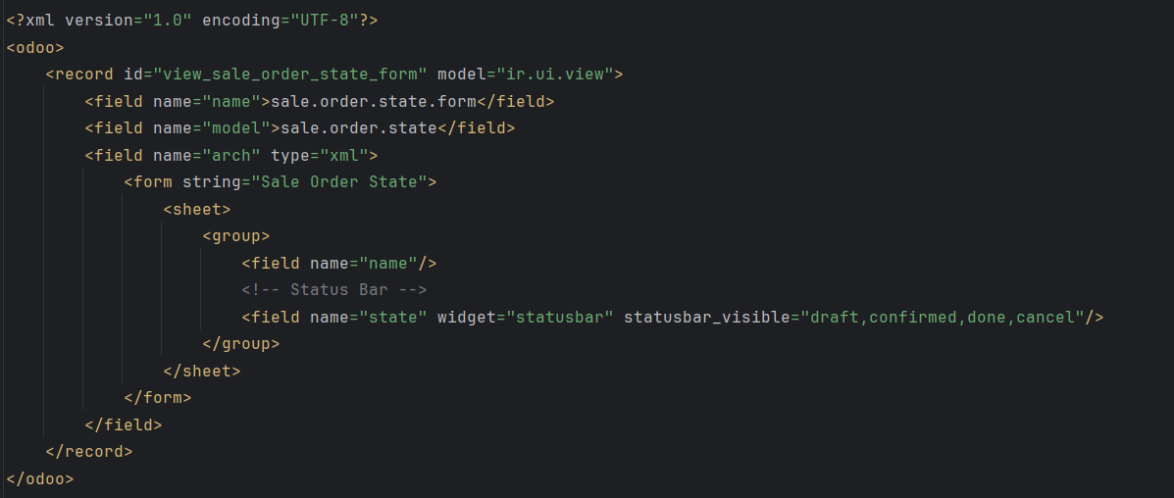

* The **widget="statusbar"** turns the state field into a status bar.
* The **statusbar_visible** attribute defines which states should be visible.

**Step 3: Add Buttons in Form View**

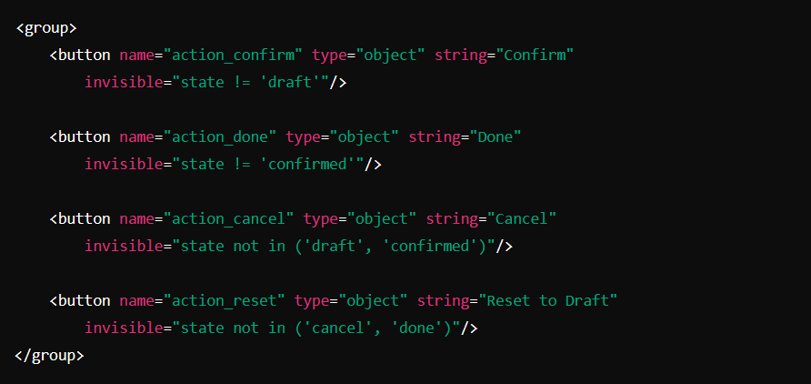

**Step 4: Add Methods in models.py**

